**University of engineering & technology Peshawar**



**COMPUTER PROGRAMMING -LAB**

**Lab report # 1**

**Fall 2020**

**Submitted by: Ashfaq Ahmad**

**Section: B**

**Reg No: 19PWCSE1795**

**Semester: 2nd**

**Submitted to:**

**Eng: Abdullah**

**Department Of Computer System Engineering**

**Introduction to IDE and Introduction to C++**

**OBJECTIVES:**

**➢ To be able to install and use Code::Blocks IDE for compiling C++ programs**

**➢ To be familiar with syntax and structure of C++ programming**

**SIMPLE C++ PROGRAM AND A TYPICAL C++ DEVELOPMENT ENVIRONMENT:**

**Step 1: Write the Source Code.**

**Step 2: Build the Executable Code.**

**Step 3: Run the Executable Code.**

**TYPICAL C++ DEVELOPMENT ENVIRONMENT:**

**Some words that will be used a lot: ▪ Source code: The stuff you type into the computer. The program you are writing. ▪ Compile: Taking source code and making a program that the computer can understand. ▪ Executable: The compiled program that the computer can run. ▪ Library: Added functions for C++. programming to do certain tasks. ▪ Header file: Files ending in .h which are included at the start of source code. Typical C++ Development Environment**

**Let's consider the steps in creating and executing a C++ application using**

**a C++ development environment. C++ systems generally consist of three**

**parts: a program development environment, the language and the C++**

**Standard Library. C++ programs typically go through six phases: edit, pre**

**process, compile, link, load and execute.**

**PHASE 1: CREATING A PROGRAM**

**Phase 1 consists of editing a file with an editor program (normally known simply as**

**an editor). You type a C++ program (typically referred to as source code) using the**

**editor, make any necessary corrections and save the program on a secondary storage**

**device, such as your hard drive. C++ source code file names often end with**

**the .cpp, extensions which indicate that a file contains C++ source code.**

**PHASES 2 AND 3: PRE PROCESSING AND COMPILING A C++ PROGRAM**

**In phase 2, the programmer gives the command to compile the program. In a C++**

**system, a pre processor program executes automatically before the compiler's**

**translation phase begins (so we call pre processing phase 2 and compiling phase 3).**

**The C++ pre processor obeys commands called pre processor directives, which**

**indicate that certain manipulations are to be performed on the program before**

**compilation. These manipulations usually include other text files to be compiled and**

**perform various text replacements.**

**PHASE 4: LINKING**

**Phase 4 is called linking. C++ programs typically contain references to**

**functions and data defined elsewhere, such as in the standard libraries or**

**in the private libraries of groups of programmers working on a particular**

**project. The object code produced by the C++ compiler typically contains**

**"Holes" due to these missing parts. A linker links the object code with the**

**Code for the missing functions to produce an executable image (with no**

**missing pieces). If the program compiles and links correctly, an executable**

**image is produced.**

**PHASE 5: LOADING**

**Phase 5 is called loading. Before a program can be executed, it must first**

**be placed in memory. This is done by the loader, which takes the**

**executable image from disk and transfers it to memory. Additional**

**components from shared libraries that support the program are also.**

**PHASE 6: EXECUTION Finally, the computer, under the control of its CPU, executes the program**

**One instruction at a time.**

**SIMPLE C++ PROGRAM:**

**A simple C++ program to calculate and display multiplication on the screen.**

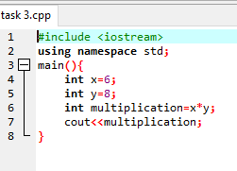

**TEST-DRIVING A C++ APPLICATION USING CODE::BLOCKS IDE:**

**Once you have downloaded the correct package, its installation is quite easy on**

**Windows. It installs like any other typical software. Finally, the Code::Blocks**

**development environments start up window .**

**CODE::BLOCKS IN ACTION**

**After you are done with installation and subsequent configuration, it's time to start**

**coding. You will observe a screen appears right after imitating this software, like in**

**Figure, that enables you to create a new project and other functionalities.**

**To start a new project, click 'Create New Project' on the screen. Here, you will**

**encounter with a huge list of predefined project templates, as in another Figure. Go**

**ahead and select "Console Application;" this will allow you to write a program for the**

**console.**

**VARIABLES AND DATA TYPES:**

**A variable is a storage location (identified by a memory address) paired with an**

**associated symbolic name (an identifier), which contains some quantity of**

**information referred to as a value. Name and type must be declared before use. TYPES OF VARIABLES**

**Variables can be categorised based on their data type. For example, in the above**

**example we have seen integer types variables. Following are the types of variables**

**available in C++.**

**int: These type of variables holds integer value.**

**char: holds character value like ‘c’, ‘F’, ‘B’, ‘p’, ‘q’ etc.**

**bool: holds boolean value true or false.**

**double: double-precision floating point value.**

**float: Single-precision floating point value.**

**LAB TASKS**

**Task no 1. Write a source code for a program to print your name.**

**Source code:**

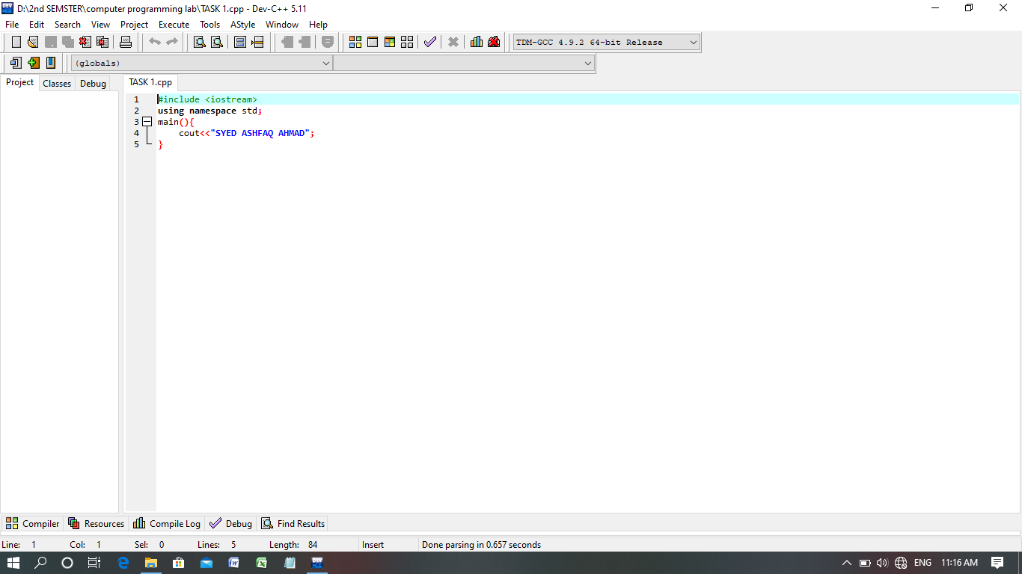

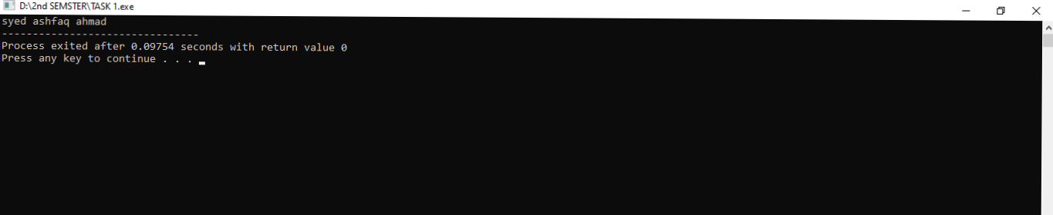

**Compilation:**

**Task 2:** write a source code for a program to multiply two integer and then display.

**Source code:**



**Compilation:**

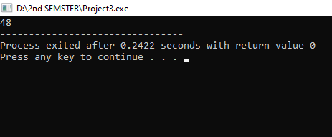

**Task 3:** Write a source code for program to find a mod and then display.

**Source code:**

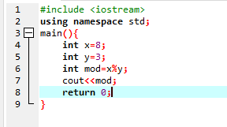

**Compilation:**

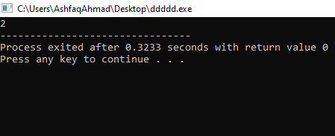

**Task 4:** Write a source code for a programme to calculate area of circle and then display.

**Source code:**

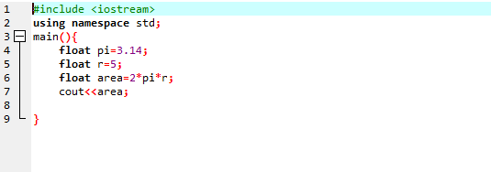

**Compilation:**

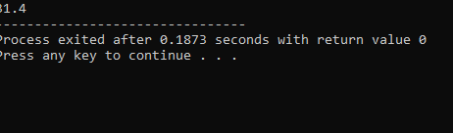

Task 5:

Write a programme to calculate area of ellipse.

Source code:

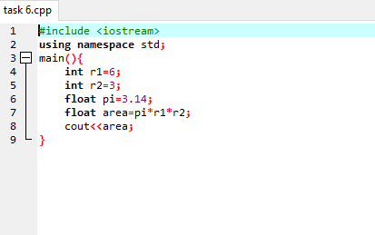

Compilation:

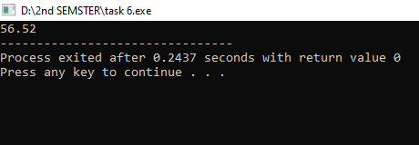

**Task 6:**  **Write a source code for a programme to calculate sum and then display.**

**Source code:**

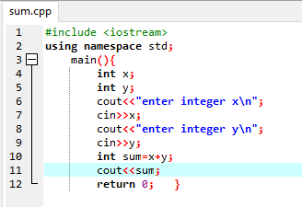

**Compilation:**

